Main content

D.2Planning an Internet Research Strategy
An Internet research strategy is necessary to avoid frustration and wasted time. A pilot or ship captain would not begin a journey without knowing the destination. Similarly, you can use a four-step plan to navigate efficiently and confidently toward your objectives:
- Review your information requirements.
- Use the proper search tools and techniques.
- Evaluate the results.
- Consider copyright and data integrity issues.
Over time, you will gain experience and develop your own preferences for using the Internet. You should remember that each research situation is unique, and several tools and techniques might be necessary to achieve the results you seek.

Step 1: Review Your Information Requirements
The first step to finding information online is to make sure you really understand what you are seeking. You need to think about the topic to ensure that you are casting an appropriate net. For example, a supervisor might ask you to help decide between two specific CASE products. Your initial inclination might be to find a review of various CASE applications. Upon reflection, however, you realize it would be more useful to understand CASE tools in a general sense before comparing specific products. Therefore, you decide to start with a more generalized search instead of going directly to vendor sites.

Step 2: Use the Proper Search Tools and Techniques
Once you feel that you understand the information required, it is time to pick an initial tool. At this point, you face some choices. Should you use search engines or other sources? Should you seek commercial sites, IT publications, professional associations, forums, or other areas to explore? What about social networking?
As you gain experience, you will be able to handle a wide range of Internet tools and resources. As with most skills, the more you use them, the more expertise you acquire. In time, you probably will develop your own list of favorite tools and resources.

Step 3: Evaluate the Results
By definition, the Internet is essentially open and unregulated. On the plus side, a huge diversity of information is available. The quality of content, however, varies greatly. Unlike published journals or textbooks, almost anyone can post content on the web. This means that the searcher must review the information very carefully. Questions to ask when accessing content include the following:

Source
Is the author identifiable? Does the author have expertise on the subject? You might need to trace back through website addresses or URLs to find biographical information or do a separate search on the author’s name.

Accuracy
Does the information come from a commercial source that is offering its own solution? Is it from an association with an inherent bias? Often, it is very difficult to find completely objective information. Identifying biases and finding information from a variety of sources are ways to address this problem.

Scope
Is the information specific enough? If not, you should narrow and refine your search and seek additional resources until you locate the information you need. When you use a search engine, one way to do this is to perform a subsearch using the results of the initial search as a starting point.

Currency
How old is the information? Is the topic static or dynamic? In the IT world, technology changes very quickly. If you locate information that appears to be out of date, you might seek more recent data to ensure that your results are valid.

Look and Feel
Is the information easy to access and navigate? If the site is designed in a logical manner and offers value-added links to worthwhile pages and resources, do not be overly concerned with style—some excellent material is created by authors and producers who focus on content, not design.
If you find the content useful, be sure to credit the source properly when you use it. You must observe legal and ethical standards when you deal with Internet material. To learn more about proper citation and to view specific examples of how to cite electronic material, you can visit the collection of student research resources at www.aresearchguide.com.

Step 4: Consider Copyright and Data Integrity Issues
Before you copy or download your search results, you must ensure that you legally can use the material and that the content is safe and free of threats.
The first issue involves copyright law. Many people regard the web as a public domain, but in reality, much of the content is intellectual property owned by a person or an organization. Some content is made available for use under a Creative Commons or open-source agreement, but to be safe, you should always look for copyright notices and restrictions. If in doubt, you might have to contact the copyright holder to seek permission.
The second issue involves data integrity. It is important to protect your network and computer system from any unwanted viruses or malware, which is malicious software that might jeopardize your security or privacy. Unlike intellectual content, which is easy to evaluate, it is impossible for you to determine the integrity and validity of the internal file structure and format without a virus detection tool. Many thousands of viruses are identified each day. Viruses and other intrusions cost businesses many millions of dollars in lost data and additional effort. Without proper protection, you run the risk of not only corrupting your own files or hard drive but also bringing your entire company network down.
If the information is legally usable and safe, you can save it to your hard drive or network, depending on the content and purpose. The information you find may be in one of many formats, including word processing documents, spreadsheets, and databases; Adobe PDF files; and multimedia material with file extensions such as .jpg, .mp3, and .mov.
Change font size
help
Main content

D.3Search Engines
As you journey on the Internet, you will use various navigation tools and techniques. To reach your destination, you must know how to use search engines properly. A search engine is an application that uses keywords and phrases to locate information on the Internet. Meta-search engines are tools that can apply multiple search engines simultaneously. For most people, search engines are the workhorses of information gathering. Search engines employ a variety of approaches to gathering information, and although they are extremely valuable, users should be aware of potential problems. For example, search results can be affected if the search engine permits commercial users to achieve higher priority based on payment of fees. Also, search engines access only a portion of the Internet.

D.3.1 Search Engine Concepts
A search engine often is the best starting point for gathering information. A well-planned search will narrow the range of content to a manageable level and will allow you to explore the choices or execute a subsearch within the focused results. As with any tool, it is important to understand the intended use and limitations of a search engine before applying it to a task.
Although many search engines exist, Google dominates the market, particularly in the all-important mobile space. Google’s appeal includes a robust package of features that users can access easily. However, when a single firm dominates a market, there is a risk that the firm’s name can become a generic verb, such as “You can Google it.”
Search engines use a specialized computer program called a spider or crawler that travels from site to site indexing, or cataloging, the contents of the pages based on keywords. The results are compiled into a database, so what you are searching is not the web itself but the contents of the search engine’s database.
No single search engine can catalog the shifting contents of the web, and even the most powerful engines do not cover all web content. If a particular site is not widely linked, or its author does not submit it to major search engines, then the material is invisible to them. Also, any website that requires a visitor to type in data, such as a name, cannot be accessed by search engines.
Although search engine indexes are incomplete and often dated, they are capable of delivering an overwhelming number of results, or hits. The real issue is quality versus quantity. When comparing search engines, it is important to know the company’s policy toward allowing commercial sites to boost their ranking in a pay for performance arrangement. Links that are subsidized by companies are called sponsored links.
Not all search engines work the same way. By understanding the underlying algorithms, or specific rules, that drive these information engines, it is possible to better target your search. For example, some sites, like Google, rank their pages by analyzing the number of other sites that link to that page. Other search engines organize results differently.
Google and Bing are indexed search engines that organize and rank the results of a search. Although they have much in common, each tool has its own search algorithms, features, and user interface.

D.3.2 Search Techniques
Consider the following suggestions when you begin a search:
- Refine your topic. Unless you limit the scope of your search, the number of results might overwhelm you. If you are looking for general information on a broad topic, consider a subject directory site.
- Translate your question into an effective search query. Searches are executed on keywords. You will improve your success if you pick the proper keywords. Try to find unique words or phrases and avoid those with multiple uses. For example, a search for the term hard drive might produce information about a computer hardware device or a difficult auto trip. Also consider using advanced search techniques, which are described in the following section.
- Review the search results and evaluate the quality of the results. If the search needs refinement or additional material, you can either use the site’s advanced search techniques or select a different Internet resource altogether.
- It is important to organize the results of your search so you can recognize and revisit important sites. Some search engines offer a personalized search history, which you can review and edit for this purpose. Many people find that the easiest solution is to create favorites or bookmarks in their browser for sites visited in important searches, using a set of folders and subfolders. If you do this, you can wait until you start the search, or you can create your filing system ahead of time.
To be effective, you should understand the mechanics of the search engine, use proper spelling, find unique phrases, and experiment with a variety of approaches. If you are consistently returning too many results, try using topic-specific terms and advanced search techniques. Conversely, if too few results are returned, eliminate the least important terms or concepts, broaden your subject, or use more general vocabulary when you select terms.

D.3.3 Advanced Search Techniques
Many search engines offer powerful advanced search features that allow you to refine and control the type of information returned from searches. These features can include the option to search within returned results and the ability to search within specific areas, such as forums. Perhaps the most powerful advanced feature is the option to use Boolean logic.
Boolean logic is a system named after British mathematician George Boole and refers to the relationships among search terms. You can use various combinations of the logical operators OR, AND, and NOT to improve your search success greatly. Figure D-1 illustrates the use of the operators with search terms. The graphics shown in the figure are called Venn diagrams. A Venn diagram uses circular symbols to illustrate Boolean logic. Venn diagrams are named after John Venn, a nineteenth-century scholar who devised a scheme for visualizing logical relationships. In the sample diagrams, the shaded area indicates the results of the search.
Figure D-1
Examples of logical operators OR, AND, and NOT. The shaded areas represent the returned results. OR is the most inclusive term, returning results if any of the terms appear. AND requires all keywords to appear. NOT excludes results even if they are found in the same document.
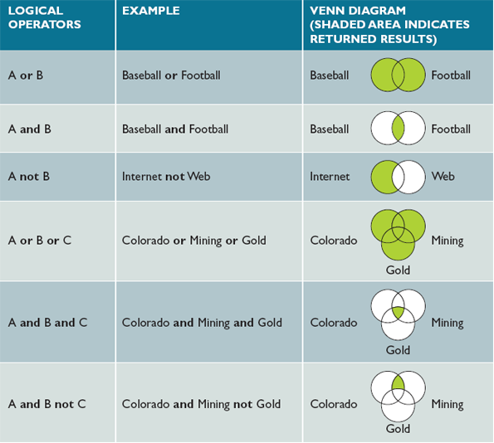
To learn more about how logical operators work, consider the following diagrams in Figure D-1:

Or
The first diagram at the top of Figure D-1 shows that the OR term will retrieve all results containing either term. Note that the shaded area includes both circles. The OR operator can be used when you need a wide search net.

And
The second diagram in Figure D-1 shows that the AND term will retrieve only those results in which all terms linked by the AND operator are present. Note that the shaded area includes only the overlapping portion of the two circles. The more terms or concepts combined in an AND search, the fewer pages will be returned. The AND operator often is used to narrow a set of search results.

Not
The third diagram in Figure D-1 shows how the NOT operator can be used to exclude certain records. In this diagram, consider the closely related terms, Internet and web. It is likely that these terms both appear in many webpages. The NOT operator will strip out the results containing the unwanted term. For example, the search string “Internet NOT web” will return only those pages with the term, Internet. You should use the NOT operator carefully, because the term you want to exclude may be intertwined with the term you seek in many documents that would be useful to you.
The last three diagrams in Figure D-1 illustrate other combinations of logical operators where three search terms are involved.

Using Phrases
Suppose you want to find sites that sell board games that require players to use strategy, such as Monopoly®. In your search, you could specify both terms, strategy AND game, but your results probably would include many documents that describe game strategies used in various sports, which is not what you are seeking. A better approach might be to search using the phrase “strategy game” enclosed in quotes. A phrase is more specific than an AND operator because it specifies an exact placement of terms. In this example, the phrase “strategy game” will not retrieve any documents unless they contain that exact phrase.
The implementation of Boolean logic varies by search engine. Some engines require the use of full Boolean searching using the complete operators (OR, AND, NOT) in the search window. Others use implied Boolean logic with keyword searching. In implied Boolean logic, symbols are used to represent Boolean operators, such as a plus sign (+) for AND and a minus sign (−) for NOT. If two search terms are entered in the search window with a space between them, some search engines may assume an OR; others assume an AND. You need to consult the site’s Help files to understand the underlying rules.

Using Fill-in Forms
Most search engines provide an advanced search feature that offers a fill-in form similar to the Google example shown in Figure D-2. Many users find it easier to fill in a form than to work with Boolean operators. The examples in Figure D-2 include sample search terms, and on its site, Google offers many more advanced search samples and tips. Note that the Google website also offers advanced search tips.
Figure D-2
Google offers advanced search capabilities with many user-selectable criteria.
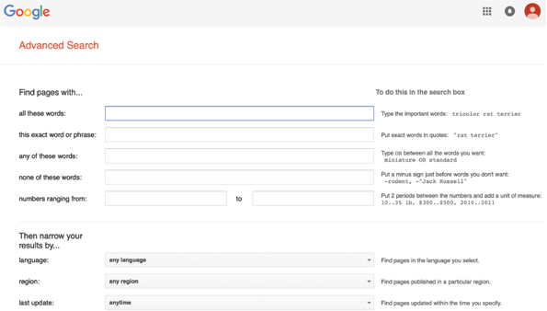
Source: Google Inc.
Change font size
help
Main content

D.4Internet Communication Channels
Suppose that you are asked to analyze your organization’s malware protection requirements. As part of your research, you would want to learn about relevant news, developments, and the latest malware threats. You also might want to suggest several specific products. Assume that you performed your research using a search engine. Now you want to check your conclusions by getting feedback from other IT professionals. There are many Internet resources available to you, available through as variety of communication channels. You can consider using social networking, forums, newsletters, blogs, podcasts, webinars, mailing lists, chat rooms, and instant messaging.

D.4.1 Social Networking
As Figure D-3 illustrates, social networking allows you to connect to an extended set of family, friends, and professional acquaintances. The “social” aspect refers to sharing of experiences and other personal items or activities that you find important. The “networking” aspect lets you build social connections in the traditional sense, with the exception that you communicate with your contacts online.
Figure D-3
Social networks let IT professionals connect with colleagues from around the world to share expertise and experience.

De Mango/ Shutterstock.com
Social networking sites such as Facebook, Twitter, and LinkedIn have gained enormous popularity in recent years. Facebook is well suited to personal connections while LinkedIn is used primarily for professional networks. Twitter limits messages (“tweets”) to 280 characters, which helps keep communication brief and to the point.
As a systems analyst, social networks are an excellent way to stay informed and to extend your sphere of influence. Twitter “tweets” and Facebook updates have largely replaced Really Simple Syndication (RSS) feeds for many in IT by providing constant updates to events of interest. However, the updates can also become a distraction if they are not used judiciously in the workplace.

D.4.2 Forums
Most people are familiar with bulletin boards they see at school, at work, and in their communities. Using thumbtacks or tape, people post information and read what others have posted. A forum, or newsgroup, is the electronic equivalent of the everyday bulletin board. Forums offer online discussions that address every conceivable subject and interest area. A forum can put you in touch with the knowledge, experience, and opinions of a large online community.
Google allows users to join thousands of groups and to create new ones if they wish. The Google site in Figure D-4 shows Google Groups, which offers a user-friendly interface and many social media features. Because of its dominant role in the search engine market, Google users have another benefit: In addition to recent content, they can search literally millions of postings that go back many years.
Figure D-4
Google Groups allows you to participate in numerous discussion groups on every imaginable topic and to create new groups.
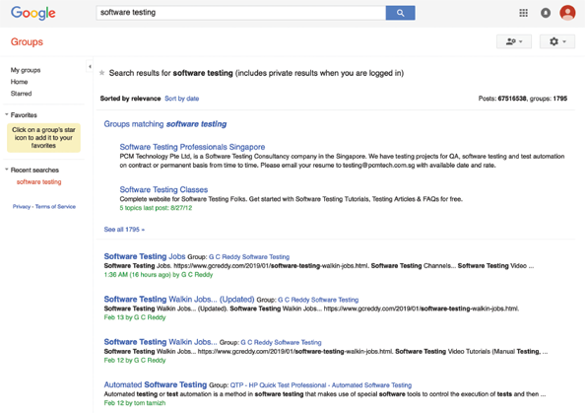
Source: Google Inc.
To understand how forums work, consider the following example. In your research on malware protection, which was mentioned in the previous section, assume that you have narrowed the product choices down to two. You are having trouble, however, differentiating between them and would like feedback from current users. You might want to visit individual product sites for user testimonials, but you would be unlikely to find a negative opinion on a vendor’s site. You could choose to send a query to people you know using your social networks, but you want to survey a variety of users that goes beyond your connections.
At this point, you might decide to tap into an appropriate newsgroup and see if there have been any postings that are relevant to you. Some forums are moderated, in which articles are sent to a person who approves them before they are posted for the group. A few forums still allow anonymous posts, but most now require valid login credentials, either with an account specific to the forum or through a trusted third party such as Facebook. A valid login means the forum owners can trace the posts back to the originator, which tends to reduce that amount of “flaming” (poor online behavior involving denigrating other users), and maintain a more polite and professional online atmosphere.
Before you post, you should read the frequently asked questions (FAQs) associated with each newsgroup. FAQs are a common method of providing guidance on questions that users are likely to ask. In many cases, FAQs describe the particular netiquette, or web guidelines for protocol and courtesy, that exist on a particular newsgroup or site.

D.4.3 Newsletters, Blogs, Podcasts, and Videos
Newsletters are a convenient way to keep current on topics of interest. Many online magazines and other groups offer free email newsletters to subscribers interested in specific topics. For example, as shown in Figure D-5, Inside readers can access a wide range of IT-related newsletters.
Figure D-5
Inside offers numerous free newsletters.

Source: GO INSIDE ( GOINSIDE.COM)
A blog is a web-based log or journal. Many computer industry experts update their blogs daily, which provide valuable information for a systems analyst. You might also consider writing your own blog—it’s a great way to help your career and maybe even help other people in your field.
A podcast is an audio blog. Podcasts are like radio shows that you can listen to at anytime and anywhere. You can subscribe to them through services such as Apple’s iTunes, which will download the latest episodes of the podcast to your computer, your smartphone, or your tablet. You can also listen to the podcasts as they stream over the Internet, without downloading the whole show. Podcasts are great ways to make productive use of downtime, such as during a commute to work or while exercising. Many tools are now available to help you record and upload your own podcasts.
Google’s YouTube is one of the most popular online video services. You can subscribe to YouTube channels that offer material ranging from entertaining to instructive. You can also create your own YouTube videos and upload them for others to view. Videos are a great way to communicate visual ideas, how-to lessons, and graphical concepts to other IT professionals.

D.4.4 RSS Feeds
The term RSS stands for Really Simple Syndication. RSS is an older format for publishing frequently updated content to users who subscribe to an RSS download, also called a feed, an RSS feed, or a web feed. Web publishers such as Google, CNN, MSNBC, and many other newspapers, magazines, vendors, and blogs use RSS feeds to distribute news and updates to subscribers, who can read the content with software called an RSS reader, a feed reader, or an aggregator.

D.4.5 Mailing Lists
A mailing list is similar to a newsgroup, which provides a forum for people who want to exchange information about specific topics. Like a newsgroup, users can post messages and view postings made by others. However, instead of a bulletin board approach, a mailing list uses email to communicate with users. A computer called a list server (listserv) directs email to people who subscribe to, or join, the mailing list.
When a person subscribes to a list, he or she can receive email messages as they are posted. Subscribers also can receive a collection of messages called a digest, which contains a summary of the postings for a specific time interval (e.g., daily). Many mailing lists are associated with websites where users can search message archives.
A systems analyst would be interested in mailing lists that focus on information technology. To locate IT-related mailing lists, you can visit the websites of professional organizations, and you can try adding the phrase “mailing list” or “listserv” to your search topic.

D.4.6 Chat Rooms
A chat room, also called a channel, is an online meeting place where users can interact and converse in real time. The chat room concept originated with IRC, which stands for Internet Relay Chat. IRC is a multichannel system supported by servers that enable group and individual conversations to occur on a worldwide basis.
Chat rooms can be used in conjunction with webinars. Instructors and students can communicate directly in chat rooms, which can help clarify question presented in the lecture material. Students can also use chat rooms to discuss common matters amongst themselves.

D.4.7 Instant Messaging and Text Messaging
Instant messaging (IM) allows online users to exchange messages immediately, even while they are working in another program or application. Users are alerted that other members of their group are available online, and users can send and receive messages or enter into a chat with other users.
Although IM began as a popular feature in home-oriented services such as AOL and Yahoo!, it has become an important business communications tool, and many firms such as IBM encourage the use of IM tools as a means of communication between employees who may be working in geographically different locations and time zones.
Corporate use of IM, however, raises serious security and privacy concerns because it is relatively uncontrolled. Also, certain industries such as banking and healthcare must observe legal regulations that govern all their communications, including IM, which must be logged and documented. Instant messages can be subject to freedom of information access requests just as emails and documents are.
Unauthorized IM and exchange of files can compromise corporate security. Applications such as Skype and other computer-based voice and video channels add a burden to network bandwidth and efficiency. To combat these threats, firms often monitor IM communication channels to limit risk to the company.
Many people use text messaging (also known as texting) to send brief written messages from one mobile phone or wireless device to another. Users can also send text messages from a computer to a handheld device. The popularity of IM and texting has given rise to hundreds of abbreviations that reduce message size and speed up the communication process. Some well-known examples include HTH (hope that helps), IDK (I don’t know), IMHO (in my humble opinion), JSYK (just so you know), LOL (laugh out loud), MIRL (meet in real life), and TYIA (thank you in advance). Overuse of IM acronyms can lead to confusing communications, just as overuse of uncommon acronyms in a written document would require a glossary to make the text understandable by the reader.
Figure D-6 shows a recap of online IT channels that can assist a systems analyst in online research and communication: social networking sites, forums, newsletters, mailing lists, chat rooms, and IM. Note that each resource has advantages and disadvantages.
Figure D-6
A recap of Internet communication channels that can assist a systems analyst in online research and communication. Note that each option has advantages and disadvantages.
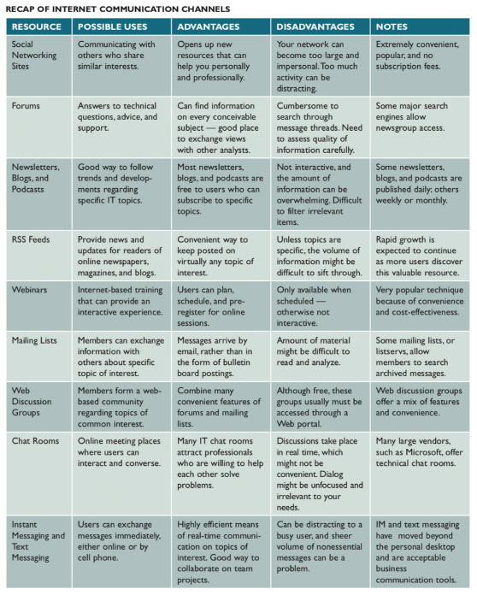
Change font size
help

